Computer Programming Using Kivy 1.7.2 - GUI 8 - Model-View-Controller
GOAL: Create a complete shopping cart simulator using the MVC way of programming.
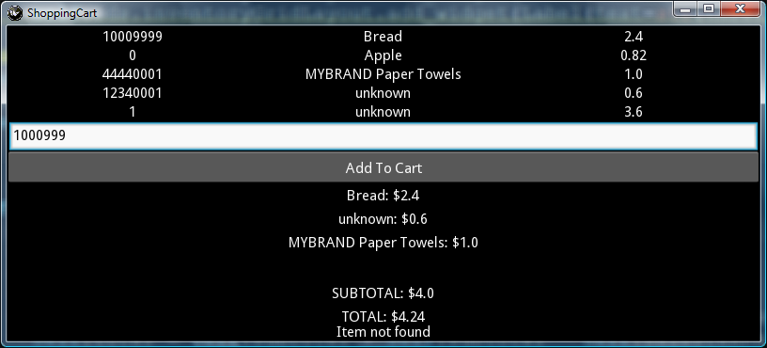

To make this program operate like a real shopping cart, there are some things missing: Prices, Subtotal, Tax, and Total. Think about how to solve this problem: to store a total and add to it later, you cannot store it in a Label, because you cannot do math on a label very well (since it is stored as text so it may contain characters other than numbers); You’ll need to make an object for each item using an item class, so that the price can be saved along with the name of the item. The same is true for all of the other data, such as lines in the shopping cart. You need to create variables or objects to store all of the data separately from the GUI. This is why the most effective way that has been used to program is called Model-View-Controller (MVC).

MVC is: a way of programming where the model (objects and variables), view (GUI or other output), and controller (gui or other input) are separate.

Normally in MVC we would create:
Model: inventory class, shopping cart class, item class
View: the GUI
Controller: addItem, removeItem, initialization, and additional methods for checkout; separate from GUI events

Since this program is only a simulator, we can it simpler by separating MVC only where most important:
Model: inventory list, cart list, and item class
View: the GUI (a kivy form)
Controller: using only a form Load method and the button event (although this is not technically MVC since the button event use the GUI framework, kivy, which cannot be separated from the view).

(continue to next page)

Computer Programming Using Kivy 1.7.2 - GUI 8 - Model-View-Controller (continued)

For our simplified Model-View-Controller experiment, you can start with a pre-made program which has the model. You’ll just need to program the controller, which in this case means modifying the addClick event for adding items:
- Open NINJA
- File, Open, Computer, StudentSharedFiles, Computer Programming, Examples, gui8cartmvc-needs-lookup.py
- File, Save As, Computer, your home drive (H:), name it gui8cartmvc.py
- Make changes to the add function so that it looks up the price by item number and changes totals:
